**PRG 155 –Programming Fundamentals Using C**

**LAB #1**

Marks: 16  
Due: Tues, Oct 1

Part 1. Pseudocode  
The objective of your pseudocode is to specify the steps of the algorithm using natural/human readable language, rather than C programming keywords.  
  
Design and write an algorithm in pseudocode that calculates the employee’s pay, based on the number of hours and hourly rate entered by the user (pay = hours x rate). The program then displays the result.  
  
Begin by creating a word document that will contain your pseudocode. the Use the following examples to write your pseudocode:

**Example 1**:  
Write an algorithm in pseudocode that calculates the sum of two input numbers and displays the result.  
  
Start  
 Input A  
 Input B  
 sum = A + B  
 Print sum  
End  
  
In this example, the Start and End terminators are used to signify the beginning and end of your algorithm. Take note of the indentation, the steps inside your terminators are indented by one tab space in order to show that these steps are contained within the main function.

**Example 2**:  
Design an algorithm that will read two numbers (A and B) and compare them. If A is greater than or equal to B, the program will display number A. If B is greater than A, the program will display number B.  
  
Start  
 Input A  
 Input B  
 If a >= B  
 Print A  
 Else  
 Print B  
End  
  
In this example a similar concept to the body of the main function is used for the inside of the body of the If-Else statement, where we indent by one tab space.

Part 2. Flowchart  
The objective of your flowchart is to specify the steps of the algorithm using a diagram (flowchart) that illustrates the flow of the program.  
  
Design a flowchart that illustrates the algorithm you’ve developed above which calculates an employees salary.  
  
Using the flowchart symbols on the following page, begin by creating a new file in one of the following applications to create your flowchart:

* **Microsoft Visio**: Seneca MyApps
* **Lucidchart**: Create a fee account at [https://app.lucidchart.com/users/registerLevel#/createAcco](https://app.lucidchart.com/users/registerLevel#/createAccount)

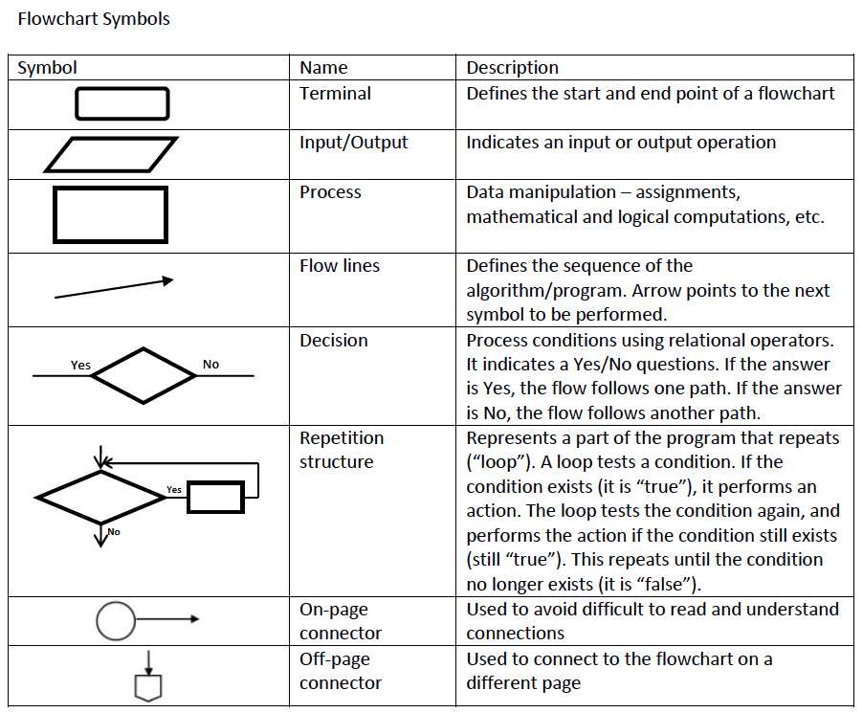

Part 3. Create a C Project  
Begin by launching Visual Studio on your computer from Seneca MyApps by logging in to <https://myapps.senecacollege.ca/>   
  
To download a copy of Visual Studio directly to your device you can find a download at the following link: <https://visualstudio.microsoft.com/vs/features/cplusplus/>  
  
Once you have successfully launched the program, select *Create a new project* from the following menu:  
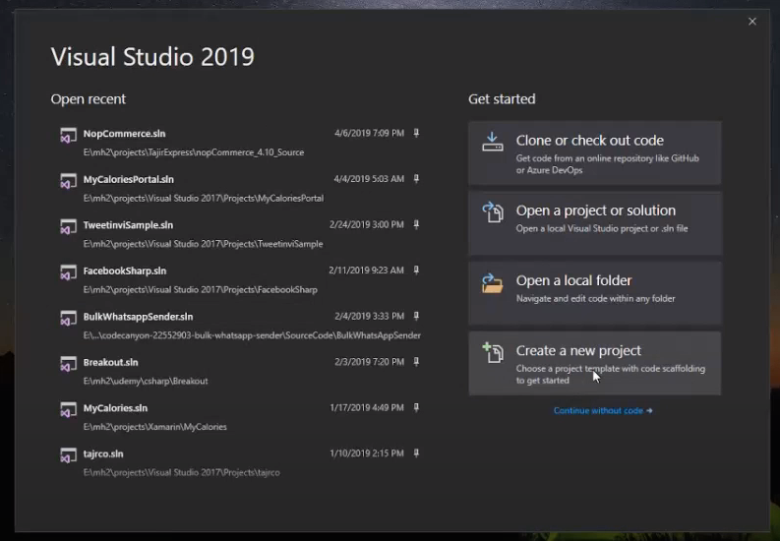  
  
  
  
  
  
  
  
  
  
From the *Create a new project* window search for and select “Empty Project”, the description should look as follows:  
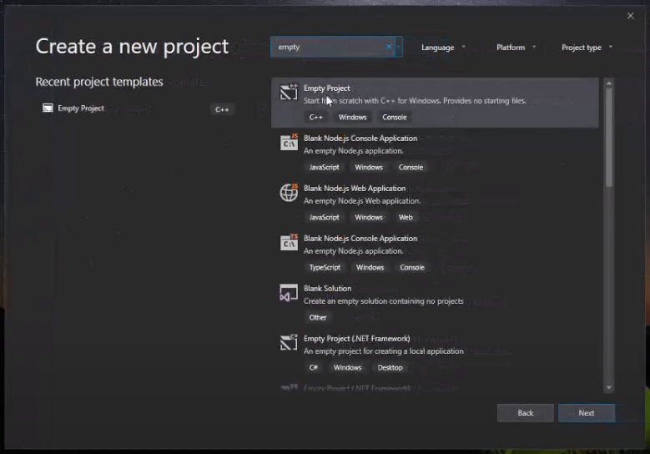  
  
You should now have a new project to begin with. From this screen, right-click on *Source Files*, then select *Add* then *New Item…*   
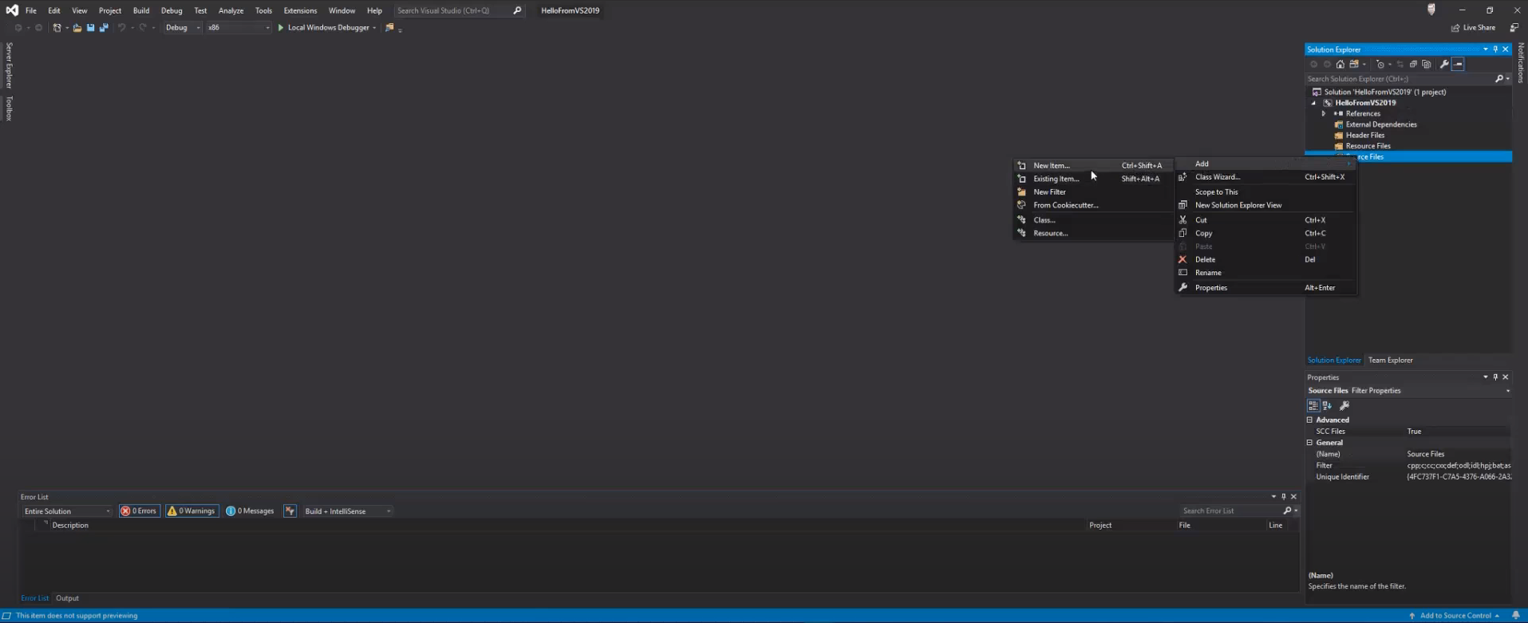  
  
  
In the *New Item* window be sure that you have Visual C++ selected, then click on C++ File(.cpp). **IMPORTANT:** Before selecting *Add*, be sure to change the extension in the name from .cpp. to .c, the .cpp extension is reserved for C++ language only.  
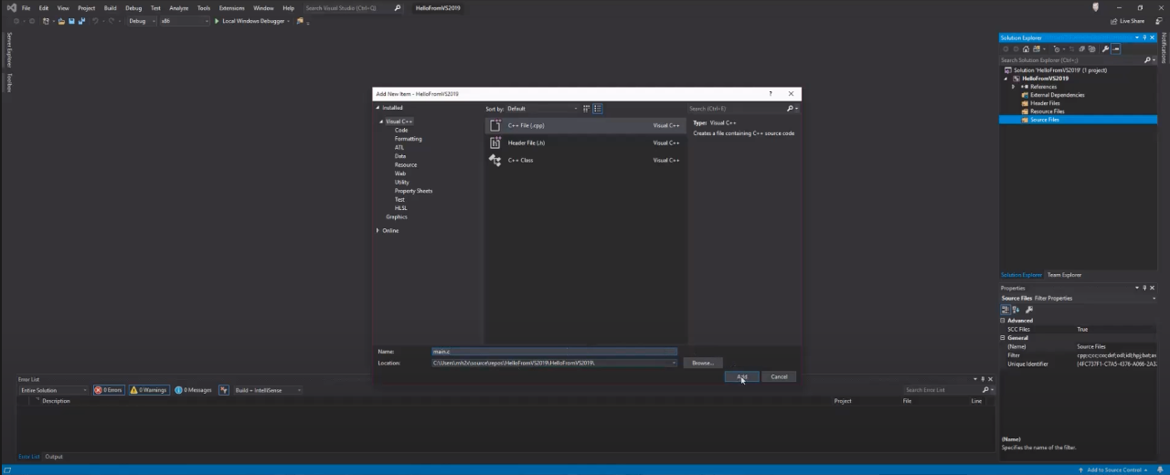  
  
Once you have created your **.c** file it is time to begin writing code!  
  
Type the following code into your **.c** file to build the program that will represent your developed algorithm:

/*

program: Lab 2

author: your_name

date: todays_date

*/

#include <stdio.h>

int main() {

int hours, rate, pay;

printf("Enter hours");

scanf("%d", &hours);

printf("Enter rate");

scanf("%d", &rate);

pay = hours * rate;

printf("%d", pay);

return 0;

}

Part 4. Submit your C project  
Save your .c file by selecting File from the Visual Studio menu bar at the top, then select *Save as .c file…*  
Login to Blackboard and submit all three files you’ve created (Pseudocode, Flowchart, .C file) to the submission dropbox.